**Create a table and insert values into it.**

Create a text document (.txt) and enter values. Use comma separated values and save it as .txt format.

warehouse#1, WA

warehouse#2,CA

warehouse#3,WA

Go to (+) create a New table and import the .txt file as a CSV file.

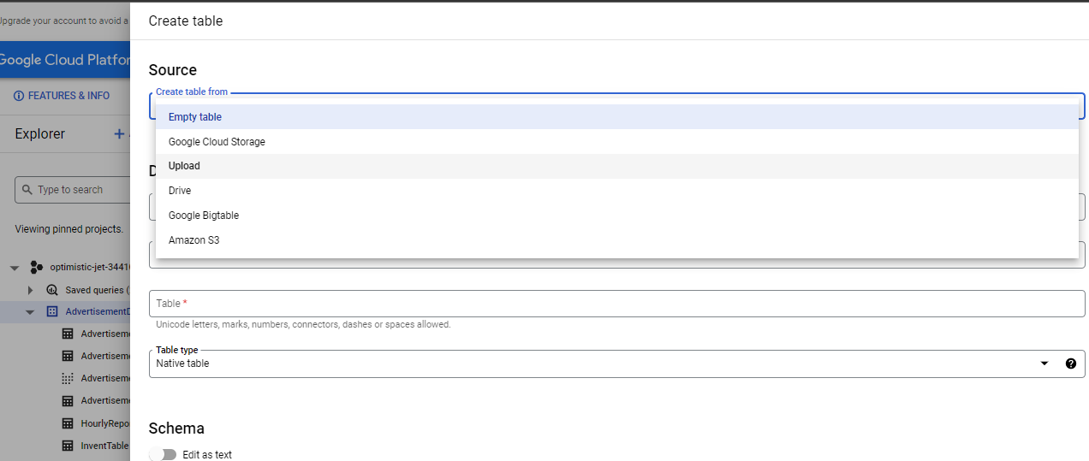

Select UPLOAD and upload the .txt file which one is a comma separated file.

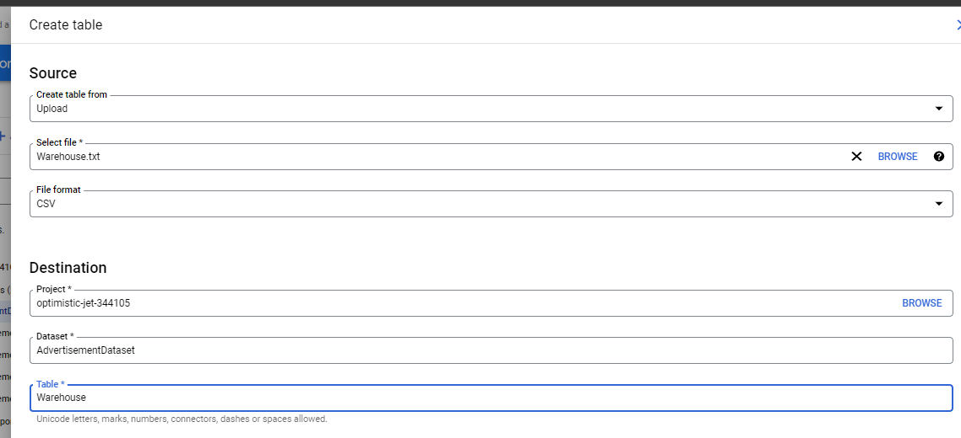

No need to change anything in *Partition and cluster settings*

Go to SCHEMA and add Fields and data types.

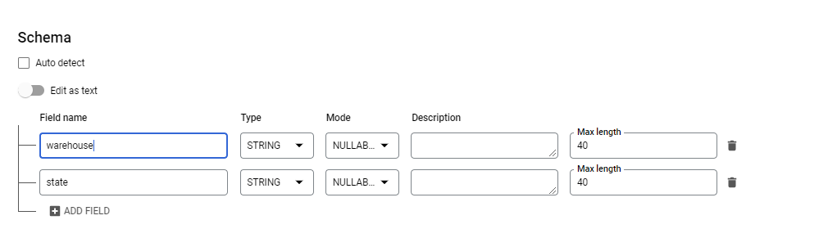

Go to *Advanced options*.

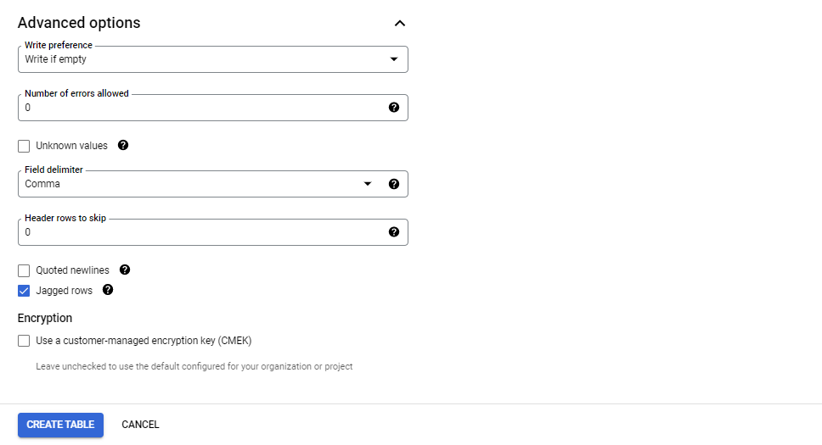

Click **CREATE TABLE**.